**Project Design Phase**

**Solution Architecture**

|  |  |
| --- | --- |
| Date | 26 june 2025 |
| Team ID | LTVIP2025TMID59401 |
| Project Name | **SmartSDLC – AI-Enhanced Software Development Lifecycle** |
| Maximum Marks | 4 Marks |

**Solution Architecture**

**Solution architecture is the foundational process that aligns business needs with technological capabilities to develop an effective system. In this project, solution architecture plays a critical role in translating real-world problems into a functional AI-powered application using IBM services.**

**Goals of the Solution Architecture**

* **Align Technology with Business Objectives:  
  Utilize IBM Watson/Watsonx and AI APIs to deliver smart, scalable, and automated responses to user prompts or business tasks.**
* **Define System Structure and Behavior:  
  Document the modules, interactions, and data flow between frontend (Streamlit), backend (FastAPI), and cloud services (IBM Cloud ML APIs).**
* **Establish Functional and Non-Functional Requirements:  
  Specify system features, input/output behaviors, security layers, and performance expectations.**
* **Guide Development and Deployment:  
  Serve as a blueprint for developers and DevOps engineers during implementation, version control, and deployment.**

**Example - Solution Architecture Diagram:**

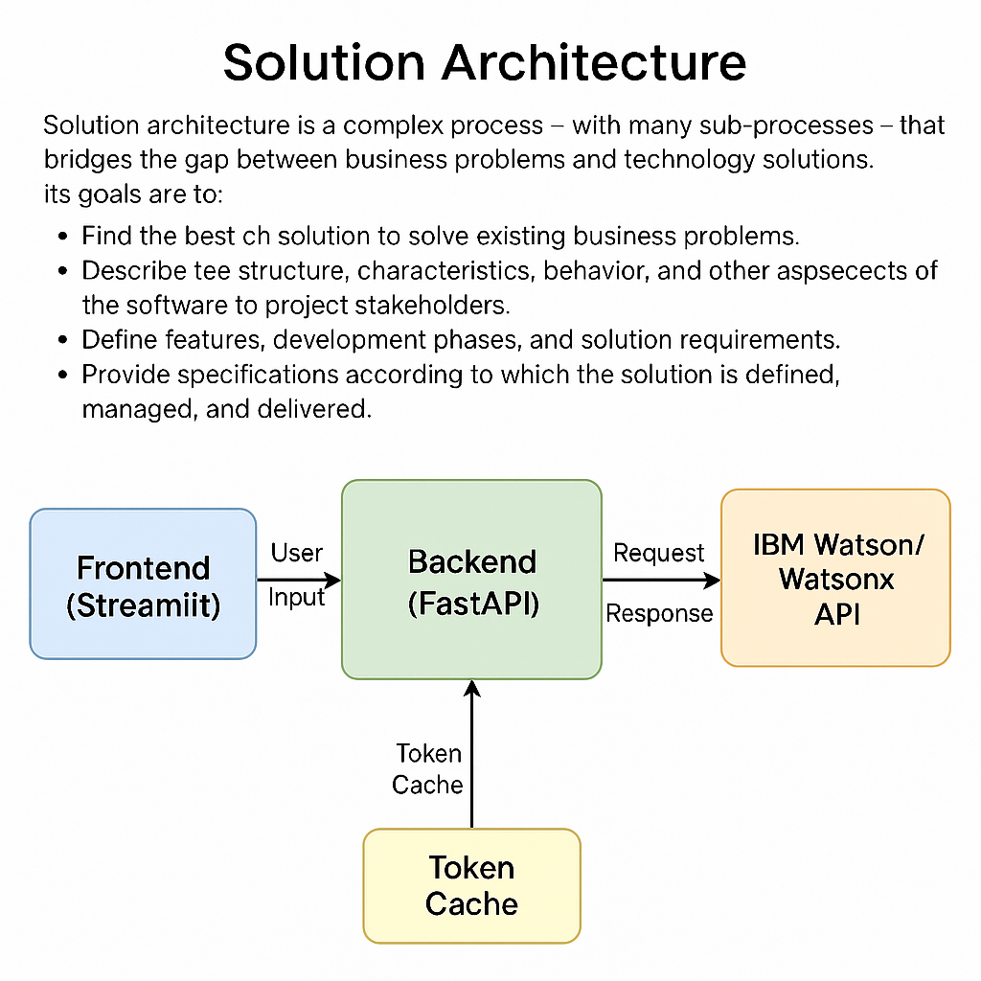

*Figure 1: Architecture and data flow of the voice patient diary sample application*